Riphah International University
I-14 Campus Islamabad
Lab_Task_02
Department: Data Science
Subject: Data Structure
Submitted By:
Hammad Sajjad Awan
SAP ID:
76142
Submitted To:
Junaid Khan
Date Of Submission:
09-09-2026

Lab Report
Lab Activity 1:
- Create a Java program using the following array:
{45, 12, 78, 23, 9, 56, 34, 89, 17, 63}
A. Traversal: Display all elements of the array using a loop.
B. Statistics: Calculate and display the sum, average, maximum, and minimum values.
C. Insertion: Insert a new value at a specified index by shifting the required elements.
D. Deletion: Delete an element from a specified index by shifting the remaining elements.
Solution:
Create a Java program using the following array:
{45, 12, 78, 23, 9, 56, 34, 89, 17, 63}
A. Traversal: Display all elements of the array using a loop.
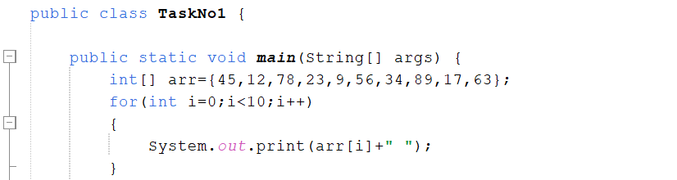
B. Statistics: Calculate and display the sum, average, maximum, and minimum values.
Sum:
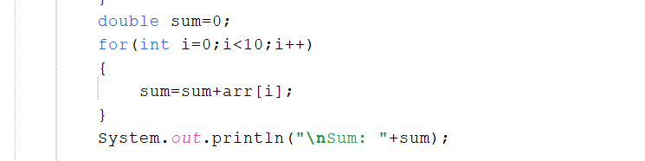
Average:

Maximum Value:
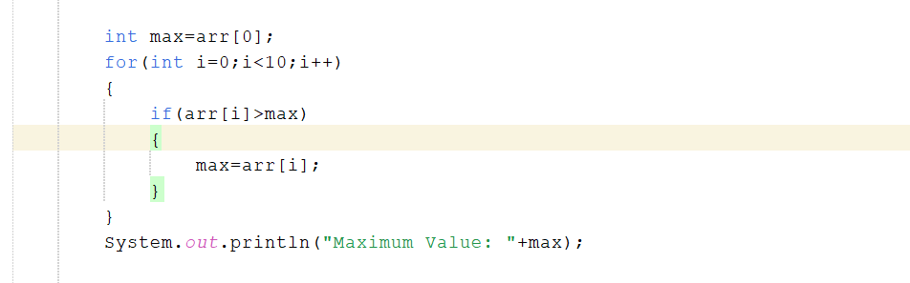
Minimum Value:
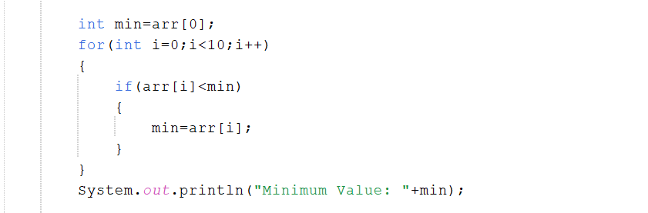
C. Insertion: Insert a new value at a specified index by shifting the required elements.
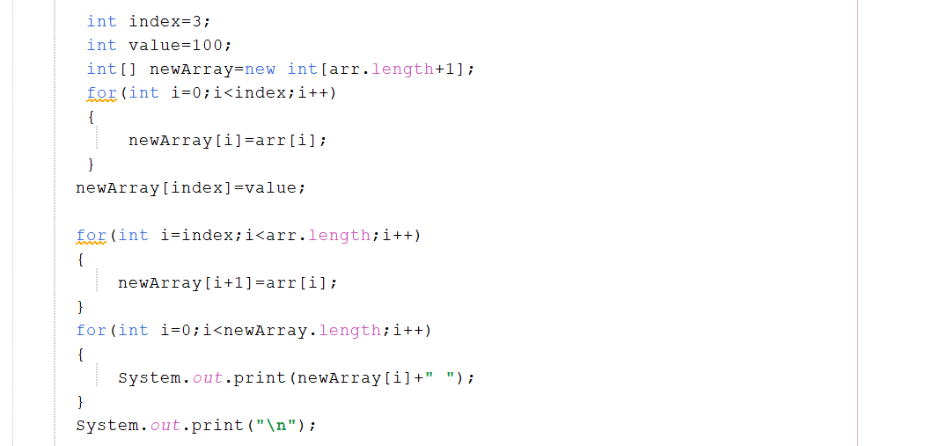
D. Deletion: Delete an element from a specified index by shifting the remaining elements.
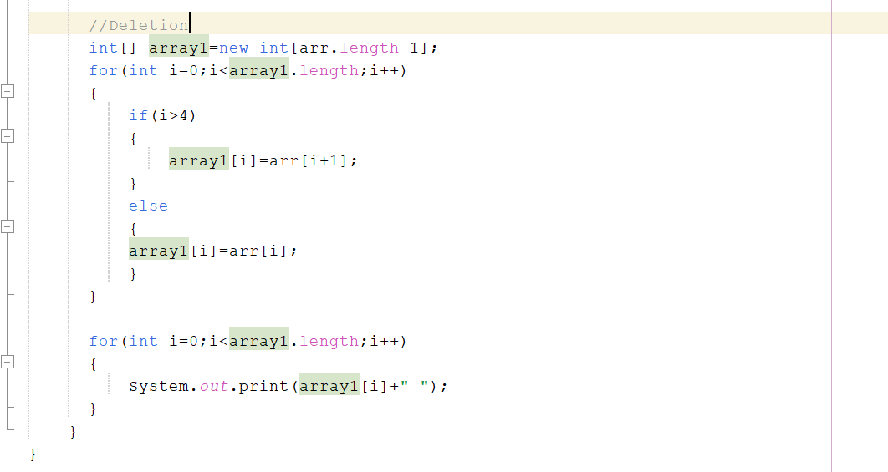
======================
- 2D Array — User Input
Create a Java program that allows the user to create and populate a two-dimensional array.
The program should:
- Ask the user to enter the number of rows and number of columns.
- Create a 2D integer array using the entered dimensions.
- Ask the user to enter the value of each element.
- Display all elements of the array using nested loops.
- Calculate and display the sum, average, maximum, and minimum values.
- Calculate and display the sum of each row.
- Calculate and display the sum of each column.

Solution:
- Ask the user to enter the number of rows and number of columns.
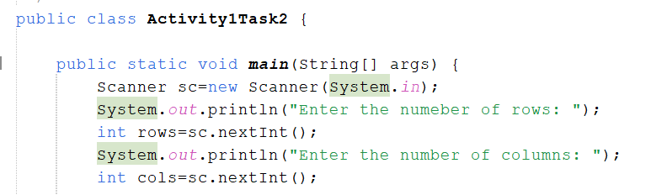
- Create a 2D integer array using the entered dimensions.
- Ask the user to enter the value of each element.
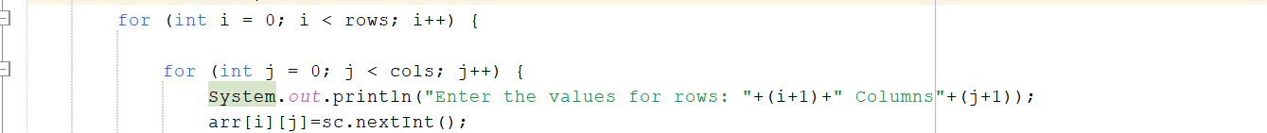
- Display all elements of the array using nested loops.
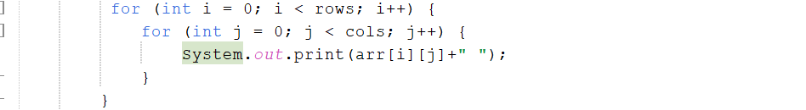
- Calculate and display the sum, average, maximum, and minimum values.
Sum:
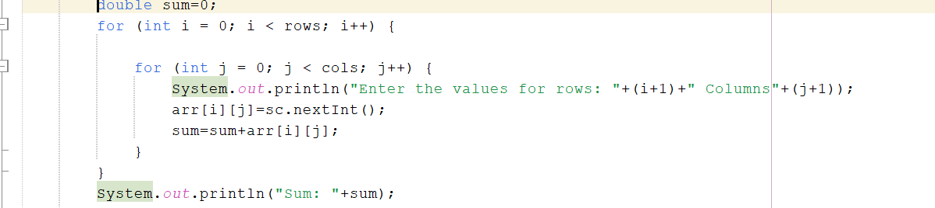
Average:
Maximum Value:
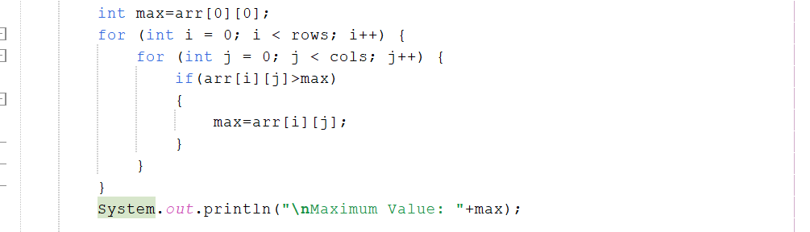
Minimum Value:
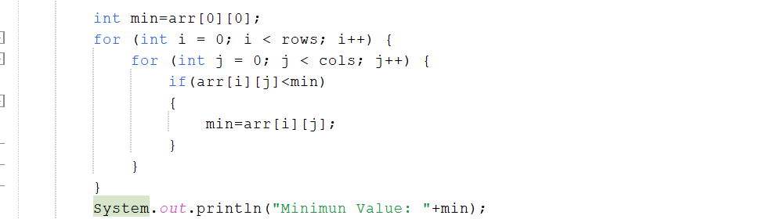
- Calculate and display the sum of each row.
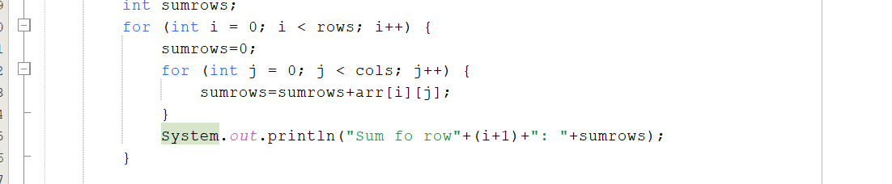

- Calculate and display the sum of each column.
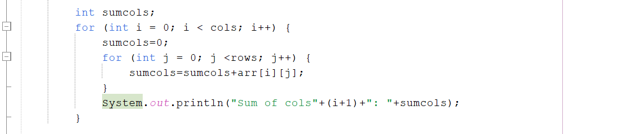
======================
- 3D Array
Create a Java program that allows the user to create and populate a three-dimensional array.
The program should:
- Ask the user to enter the number of layers, rows, and columns.
- Create a 3D integer array using the entered dimensions.
- Ask the user to enter the value of each element.
- Display all elements of the 3D array using nested loops.
- Calculate and display the sum, average, maximum, and minimum values.
- Calculate and display the sum of each layer.
- Ask the user to enter a value to search in the 3D array.
- If the value is found, display its layer, row, and column position. Otherwise, display an appropriate message.
Solution:
- Ask the user to enter the number of layers, rows, and columns.
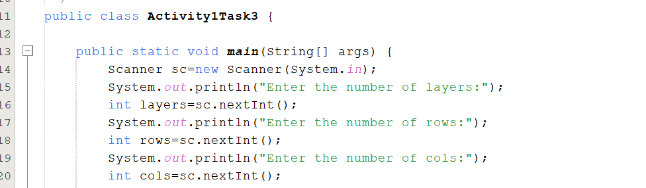
- Create a 3D integer array using the entered dimensions.
- Ask the user to enter the value of each element.
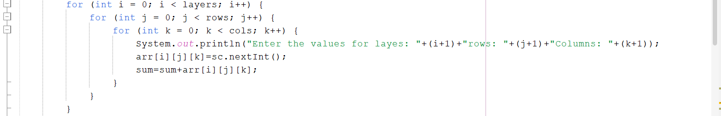
- Display all elements of the 3D array using nested loops.

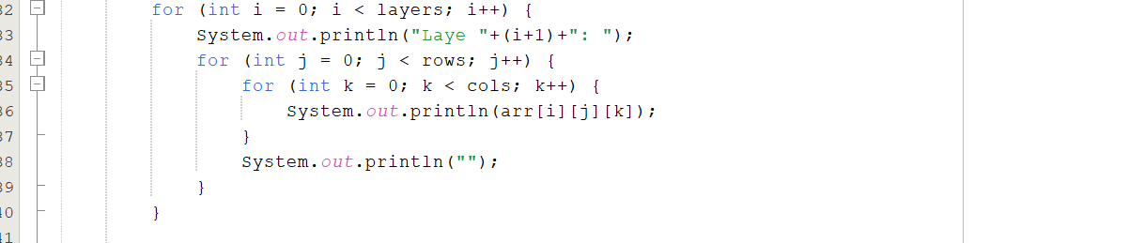
- Calculate and display the sum, average, maximum, and minimum values.
Sum:
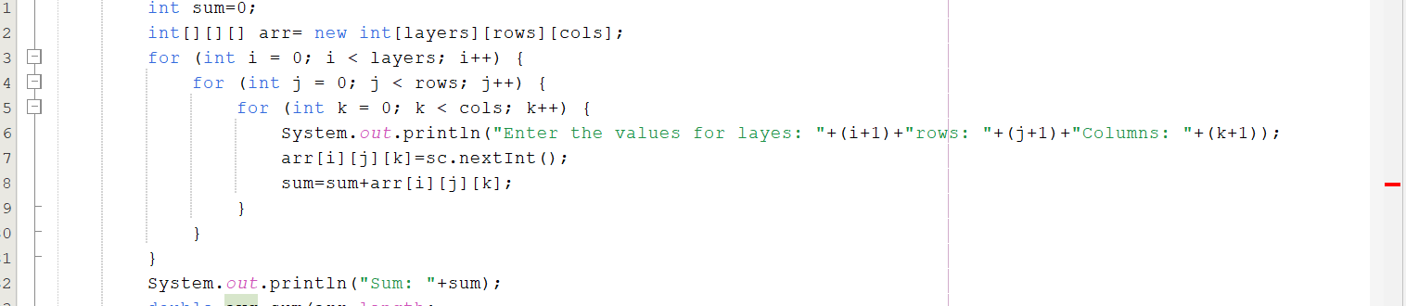
Average:
Maximum Value:
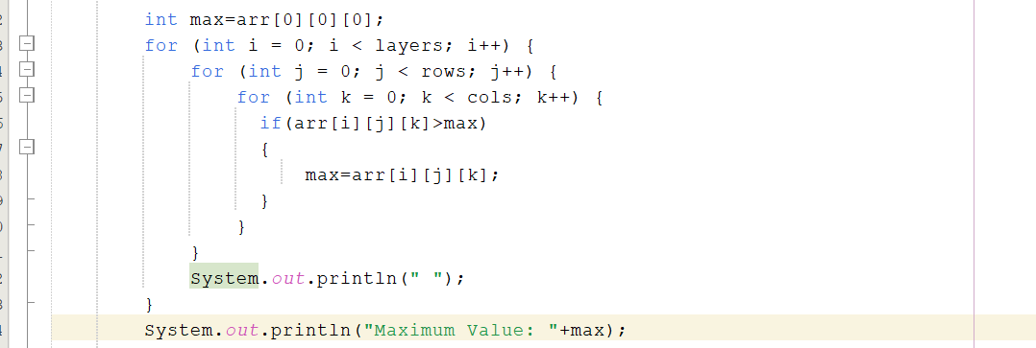
Minimum Value:
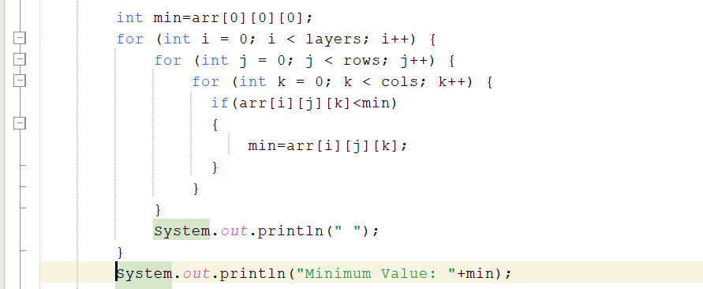
- Calculate and display the sum of each layer.
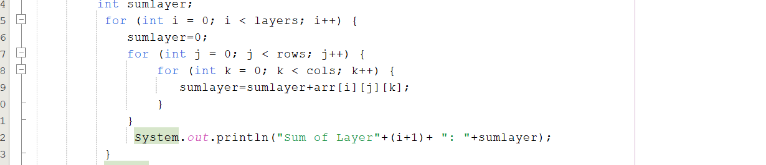

- Ask the user to enter a value to search in the 3D array.
- If the value is found, display its layer, row, and column position. Otherwise, display an appropriate message.
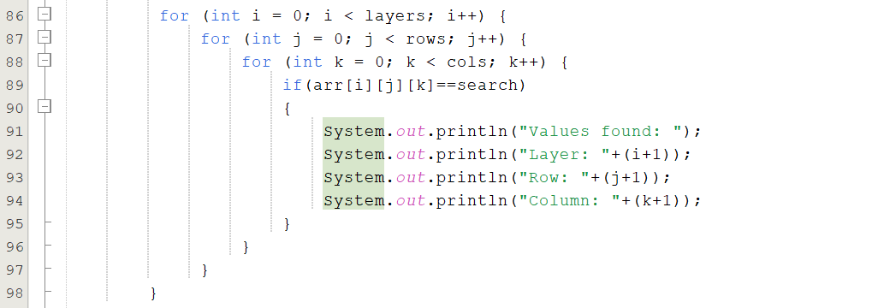
======================
Lab Activity 2:

Activity 2 — Sorting Algorithms
Create separate methods to sort the following array in ascending order:
{64, 25, 12, 22, 11, 90, 34}
Bubble Sort: Repeatedly compare adjacent elements and swap them when they are in the wrong order.
Selection Sort: Find the smallest element from the unsorted portion and place it at the correct position.
Insertion Sort: Build the sorted portion one element at a time by inserting each element into its correct position.
Display the original array and the final sorted array for each algorithm. Observe how the three algorithms produce the same sorted result using different approaches.

Solution:
Bubble Sort: Repeatedly compare adjacent elements and swap them when they are in the wrong order.
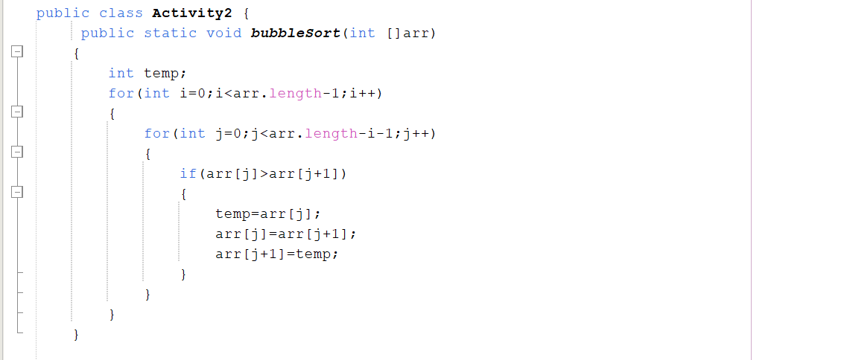
Selection Sort: Find the smallest element from the unsorted portion and place it at the correct position.
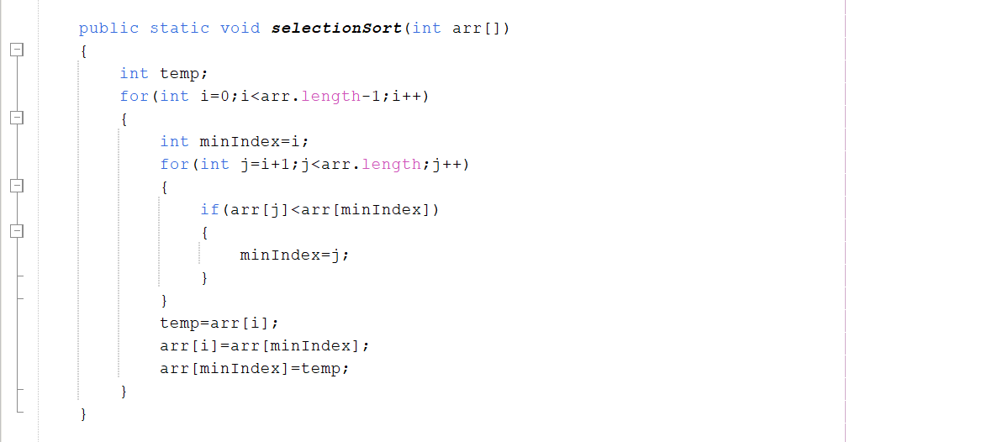
Insertion Sort: Build the sorted portion one element at a time by inserting each element into its correct position.
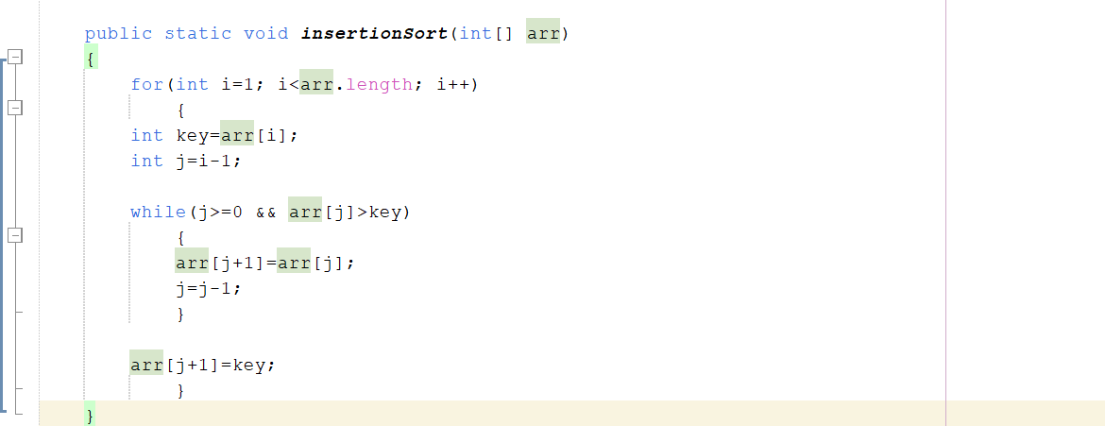
Display the original array and the final sorted array for each algorithm. Observe how the three algorithms produce the same sorted result using different approaches.

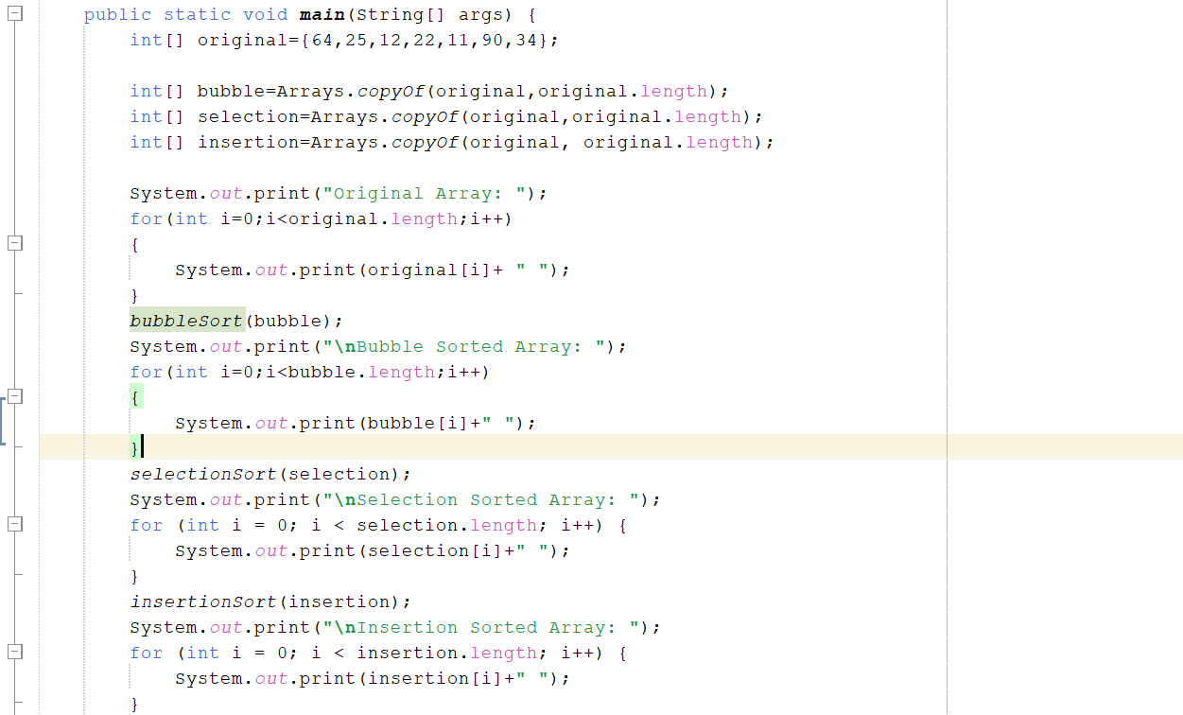
======================
Lab Activity 3:

Activity 3 — Singly Linked List
Implement a singly linked list using a Node class. Each node should contain an integer data value and a reference to the next node.
Node structure:
class Node {
int data;
Node next;

Node(int data) {
this.data = data;
this.next = null;
}
}
Create the following initial linked list:
10 → 20 → 30 → 40 → 50 → null
A. Create & Traverse: Create the nodes, connect them, and display all elements from head to null.
B. Insert at Beginning: Add a new node before the current head.
C. Insert at End: Add a new node after the current last node.
D. Search: Search for a given value by traversing the list.
E. Delete: Delete a node containing a specified value and reconnect the remaining nodes.
F. Display: Display the final linked list after all operations.
Solution:
A. Create & Traverse: Create the nodes, connect them, and display all elements from head to null.
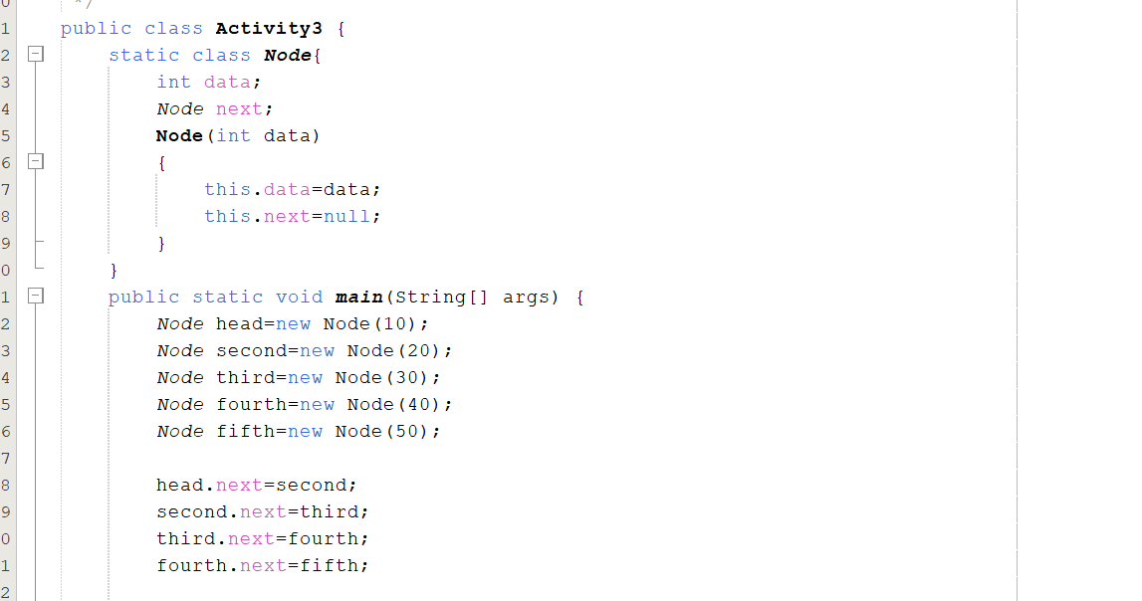
B. Insert at Beginning: Add a new node before the current head.
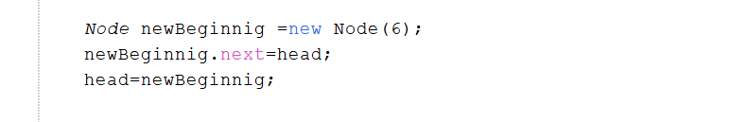
C. Insert at End: Add a new node after the current last node.
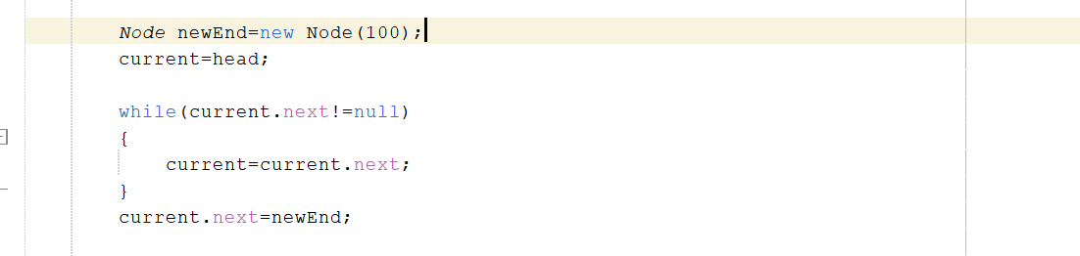
D. Search: Search for a given value by traversing the list.
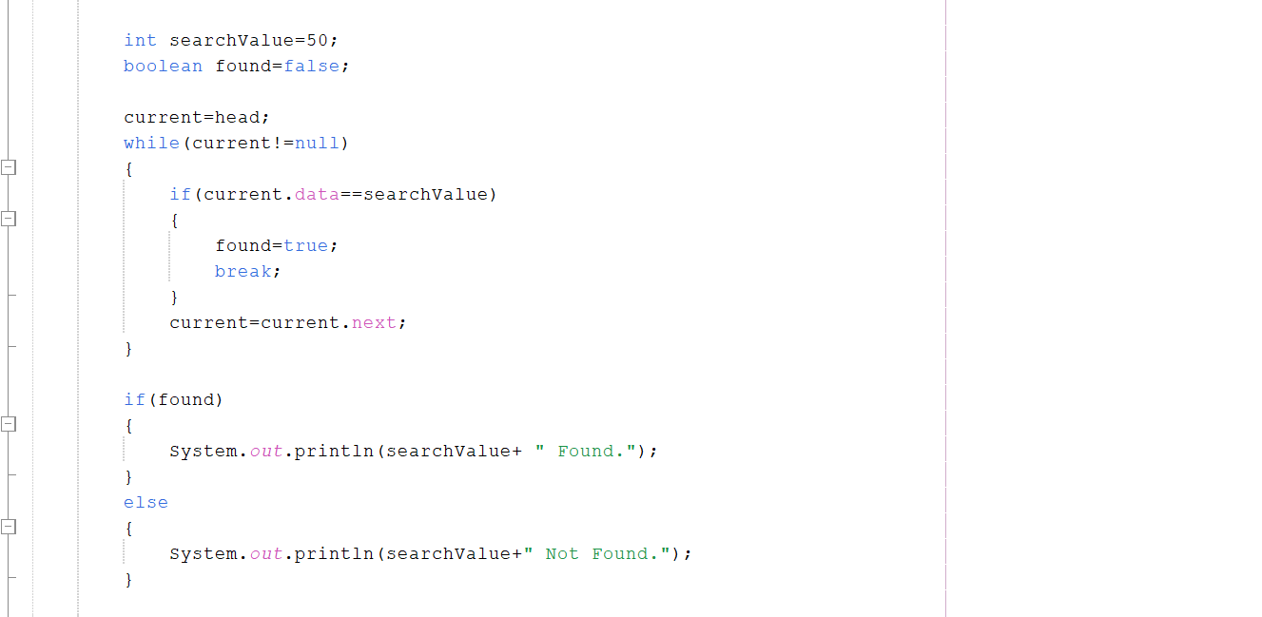
E. Delete: Delete a node containing a specified value and reconnect the remaining nodes.
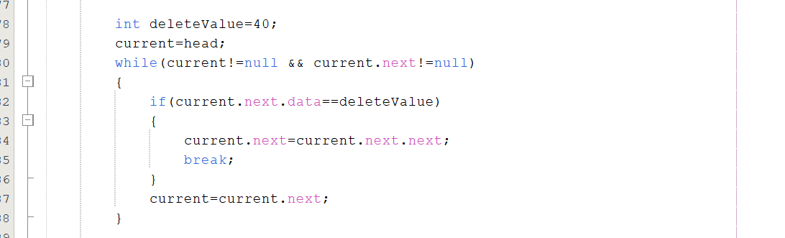
F. Display: Display the final linked list after all operations.
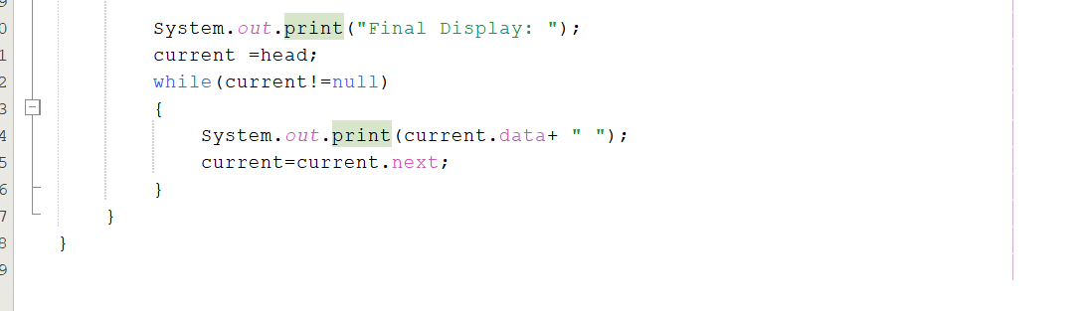
======================
Bonus Task

4. Bonus Task— Student Marks Manager
Develop a small Java program that stores student marks using both an array and a singly linked list. The program should demonstrate the operations learned in this lab.
- Store and display marks using an array.
- Calculate maximum, minimum, and average marks.
- Sort the marks using at least one of the three sorting algorithms.
- Store the same marks in a singly linked list.
- Insert and delete a mark from the linked list.
- Display the final contents of both structures.
Solution:
- Store and display marks using an array.
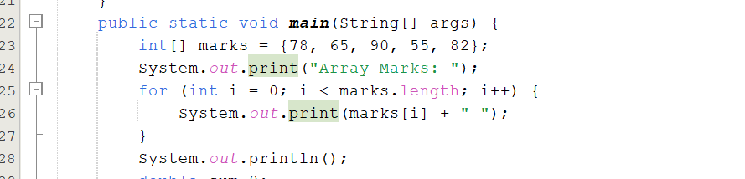

- Calculate maximum, minimum, and average marks.
Maximum Marks:
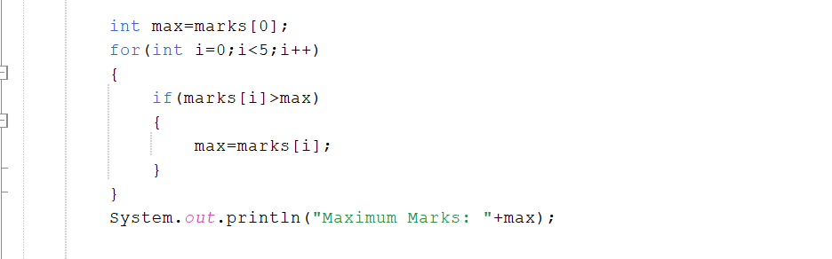
Minimum Marks:
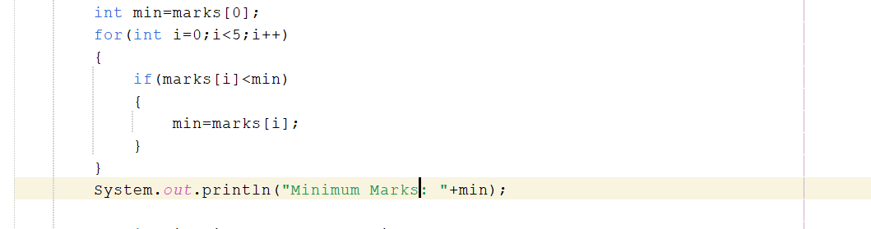Average:
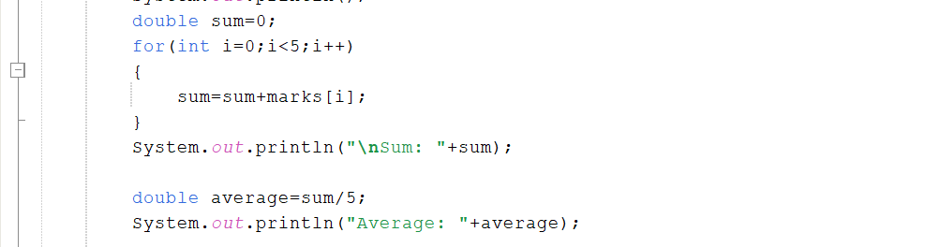
- Sort the marks using at least one of the three sorting algorithms.
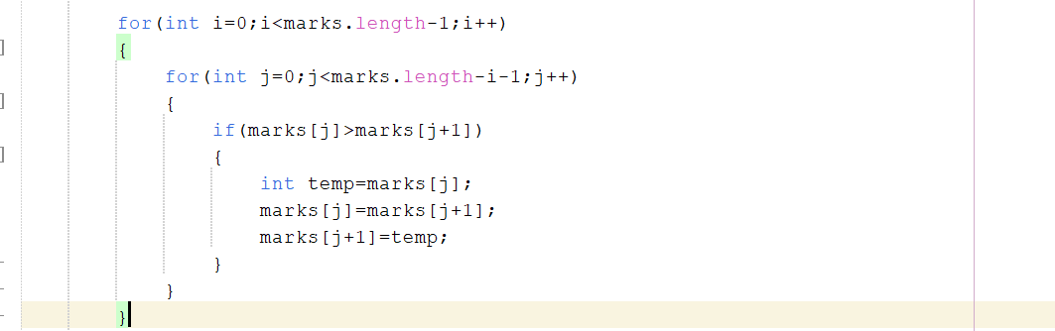
- Store the same marks in a singly linked list.
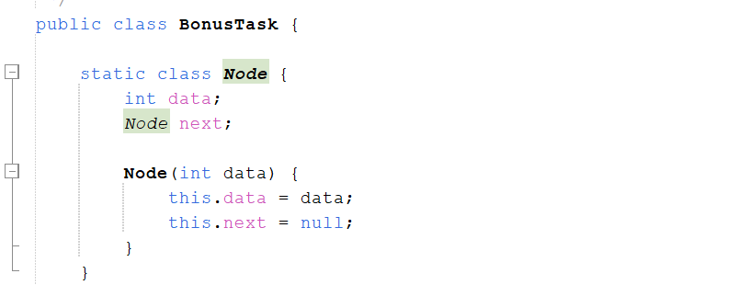
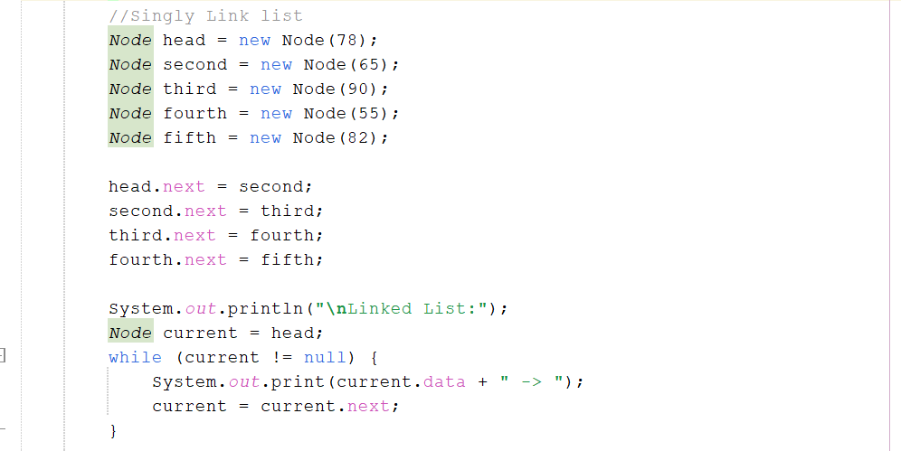
- Insert and delete a mark from the linked list.
Insert:

Delete:
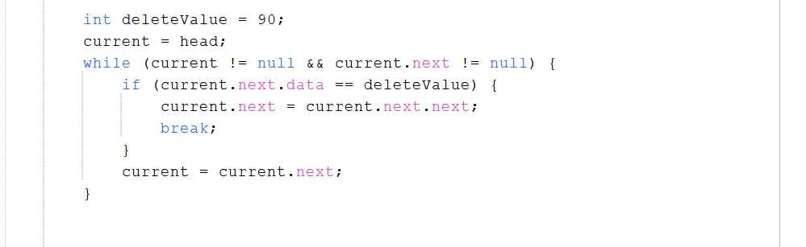
- Display the final contents of the both structures.
Final Link List Array:
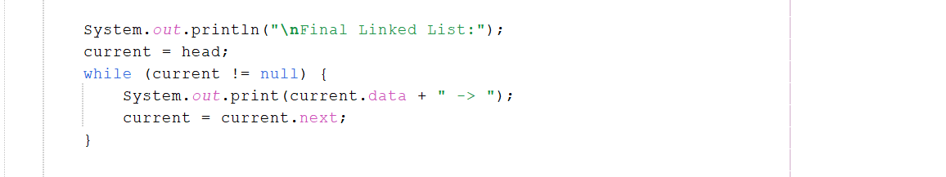
Final Array:



